Mosaic Technique
By Marcia Stivelman
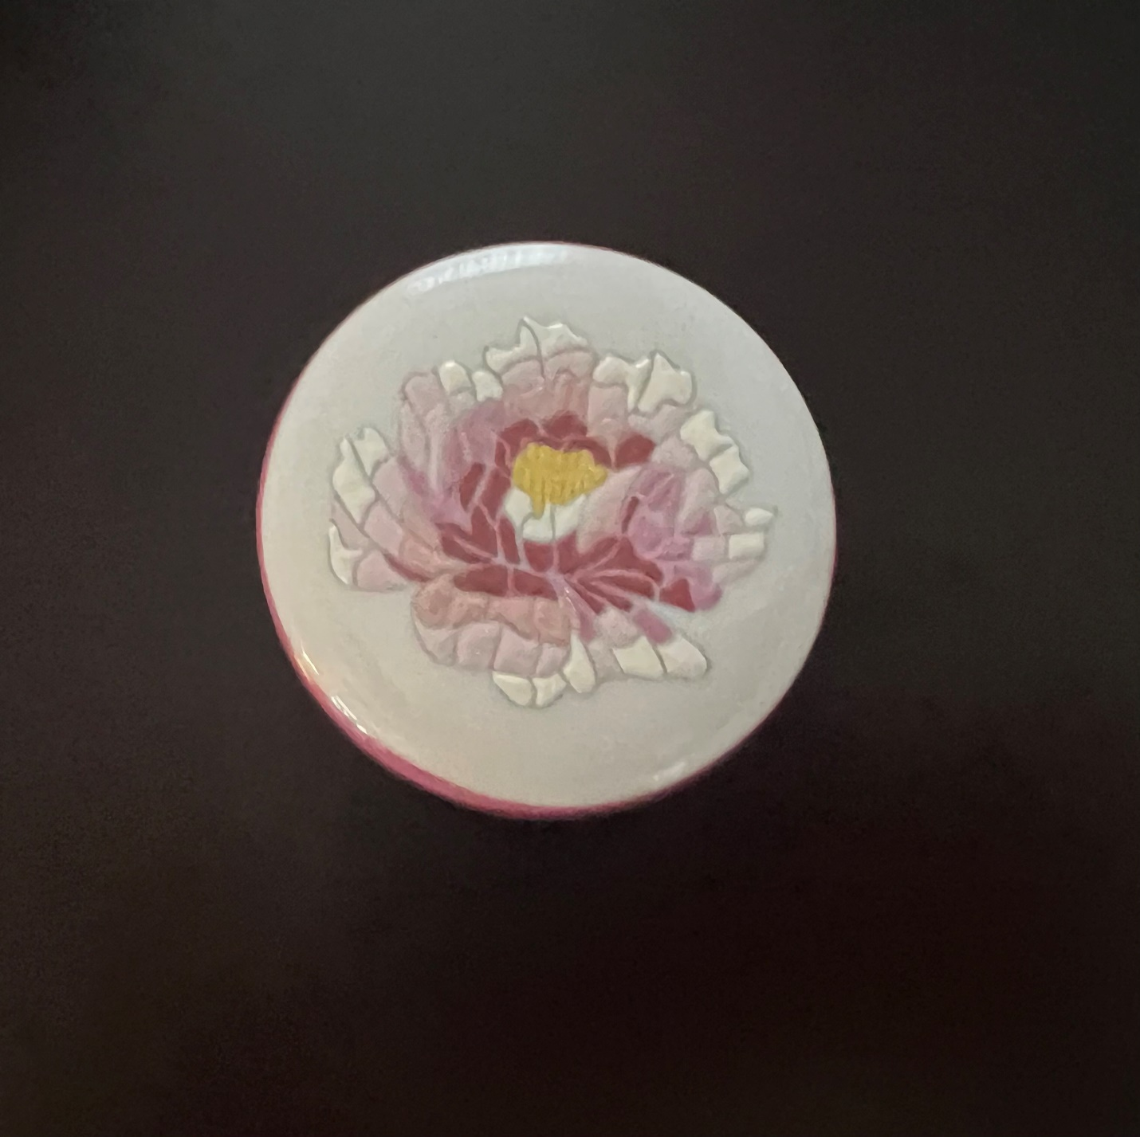
Mosaic is a word that comes from the Greek and means patience from the Goddess. That means a technique that requires a lot of patience, however when completed it is so rich and beautiful that is only suitable for the Goddess.

The difficulty is to find the design suitable for mosaic.
Choose a flat piece with preferably soft glaze like Pickard, bone china or even ceramic.
Clean with alcohol.
Trace the design on the porcelain. Follow the curves of the design to make a mosaic look tridimensional.
Penwork with black or the color that you want to paint the mosaic. The size of the little squares should be between 2mm and 3 mm. Not too big otherwise it is difficult to fill the squares. Fire and that starts the fun.
Materials for Mosaic:
-Enamel powder in different colors or with white enamel plus flux for glass plus powder colors or non ping plus powder colors.
-Enamel medium or pine grease or MX54 or heavy copaiba
-Turpentine and container for turpentine
-Mop brush, very thin round synthetic brush
-Tile for mixing
-needle and toothpicks

